This document covers the following use cases:
- Merging multiple persistence units in to one.
- Using Fetch Groups
- Named Fetch Groups
- Dynamic Fetch Groups
- Overriding named queries defined in parent module with the named queries defined in sub modules or extensions.
- Marshalling entities (to Json or XML) having lazy attributes.

Merging multiple persistence units
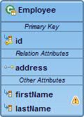
CompositePU
Module2

Module1

- CompositePU:

<persistence-unit name="CompositePU" transaction-type="RESOURCE_LOCAL">
<provider>org.eclipse.persistence.jpa.PersistenceProvider</provider>
<mapping-file>META-INF/orm.xml</mapping-file>
<jar-file>module1.jar</jar-file>
<jar-file>module2.jar</jar-file>
<exclude-unlisted-classes>true</exclude-unlisted-classes>
<properties>
<property name="eclipselink.composite-unit" value="false"/>
<property name="javax.persistence.jdbc.driver" value="oracle.jdbc.OracleDriver" />
<property name="javax.persistence.jdbc.url" value="jdbc:oracle:thin:@localhost:1521:xe" />
<property name="javax.persistence.jdbc.user" value="compositepu" />
<property name="javax.persistence.jdbc.password" value="admin" />
<property name="eclipselink.target-database" value="Oracle" />
<property name="eclipselink.weaving" value="true" />
</properties>
</persistence-unit>
- Define all global properties like datasource details,weaving options,logging details etc in parent modules persistence.xml
- Define a property called eclipselink.composite-unit=false.This is not a mandatory property as by default its value is false.
- List out the submodule’s jars.(module1.jar,module2.jar)

- Module1-PU:
<persistence-unit name="module1-pu" transaction-type="RESOURCE_LOCAL">
<provider>org.eclipse.persistence.jpa.PersistenceProvider</provider>
<class>module1.model.Employee</class>
<exclude-unlisted-classes>true</exclude-unlisted-classes>
<properties>
<property name="eclipselink.composite-unit.member" value="true" />
</properties>
</persistence-unit>

- Module2-PU:
<persistence-unit name="module2-pu" transaction-type="RESOURCE_LOCAL">
<provider>org.eclipse.persistence.jpa.PersistenceProvider</provider>
<class>module2.model.Address</class>
<exclude-unlisted-classes>true</exclude-unlisted-classes>
<properties>
<property name="eclipselink.composite-unit.member" value="true" />
</properties>
</persistence-unit>
- Define a property called eclipselink.composite-unit.member =true.This is a mandatory property.If the value is false then you can’t have entities that have associations with other entities defined in a different modules’ PU. Here Employee entity in module1 has a many-to-one association with Address entity in module2.

Using Fetch Groups

Lazy attributes can make queries more efficient by delaying the loading of data. EclipseLink offers a feature called Fetch Groups that allows you to define multiple lazy attribute configurations and apply those on a per-query basis. Attributes are fully lazy accessible and accessing an unfetched attribute will cause the Entity attributes to be loaded as per the static lazy configuration from the Entity metadata.

Using Named Fetch Groups:
Steps:
- Define fetch groups for a particular entity in eclipselink-orm.xml
<entity class="module1.model.Employee">

<fetch-group name="onlyFirstName">
<attribute name="firstName" />
</fetch-group>

<fetch-group name="onlyLastName">
<attribute name="lastName" />
</fetch-group>

<fetch-group name="withAddress" load="true">
<attribute name="firstName" />
<attribute name="lastName" />
<attribute name="address" />
</fetch-group>
</entity>
- Set the fetch group query hint on the query with any of the defined fetch group names.
TypedQuery<Employee> query=getEntityManager().createNamedQuery("Employee.findById",Employee.class);
query.setParameter("id",10L);
query.setHint(QueryHints.FETCH_GROUP_NAME, "onlyLastName");
Employee emp=query.getSingleResult();

Using Dynamic Fetch Groups:
Steps:
- Define a fetch group
//Define a dynamic fetch group
FetchGroup group = new FetchGroup();
//Add fetch group attributes
group.addAttribute("firstName");
group.addAttribute("address");

- Set the query hint and execute the query.

TypedQuery<Employee> query=getEntityManager().createNamedQuery("Employee.findById",Employee.class);
query.setParameter("id",10L);
query.setHint(QueryHints.FETCH_GROUP, group);
Employee emp=query.getSingleResult();

Overriding Named Queries

A named-query is unique by name. The named-query defined in EclipseLink-ORM.XML overrides named-query of the same name defined in other mapping files. Outside of the overriding case, an exception is thrown if two or more named-query elements with the same name are defined in one or across multiple mapping files.

In our design the named query defined in eclipselink-orm.xml of any sub modules overrides named query of the same name defined in orm.xml mapping file of the parent module.

Note: The eclipselink log for the sample application

Ignoring the element [<named-query>] named [Employee.findById] defined in the mapping file [file:/D:/PK_SPACE/POCS/CompositePU/CompositePU/bin/META-INF/orm.xml] since an element with the same name was defined in the eclipselink-orm mapping file [jar:file:/D:/PK_SPACE/POCS/CompositePU/CompositePU/bin/pu1.jar!/META-INF/eclipselink-orm.xml]

Marshalling entities

JPA often uses lazy loading on properties. If you use property access in JAXB then it will trigger these lazy properties during a marshal. Also in order to support lazy loading (or change tracking, etc) some JPA implementations use byte code manipulation to introduce fields onto classes to enable this. Using field access with JAXB can cause errors when using this type of JPA implementation. Eclipselink uses byte code manipulation to support lazy loading and other features. So use property access in JAXB. But the issue is while marshalling an entity it ends up by populating every attributes, even lazy attributes.
JAXB (JSR-222) is configuration by exception, meaning that there is a default mapping applied to domain objects. The default one is @XmlAccessorType(XmlAccessType.PROPERTY) .This means that while marshalling or un-marshalling jaxb uses java bean properties(getters and setters) to get or set the values. Other available mapping options are @XmlAccessorType (XmlAccessType.FIELD) and @XmlAccessorType (XmlAccessType.NONE). By setting @XmlAccessorType (XmlAccessType.NONE) we are disabling configuration by exception. Now only explicitly mapped fields/properties will be mapped.
So the solution to avoid marshalling of lazy attribute is to use @XmlAccessorType (XmlAccessType.NONE) and use field/property mapping for non-lazy attributes and field mapping for lazy attributes. This can be done using annotations or an external moxy oxm mapping .Both the approaches are shown below:
Example:-
The JPA entity:
@Entity
@Table(name = "EMPLOYEES")
public class Employee{
private Long id;
private String firstName;
private String lastName;
private Address address;

@Id
@GeneratedValue(generator="EMP_GEN",strategy=GenerationType.TABLE)
@Column(name = "EMP_ID")
public Long getId() {
return id;
}

public void setId(Long id) {
this.id = id;
}

@Column(name = "FIRST_NAME")
public String getFirstName() {
return firstName;
}

public void setFirstName(String firstName) {
this.firstName = firstName;
}

@Column(name = "LAST_NAME")
public String getLastName() {
return lastName;
}

public void setLastName(String lastName) {
this.lastName = lastName;
}

@OneToOne(orphanRemoval = true, cascade = ALL, fetch = FetchType.LAZY)
@JoinColumn(name = "ADD_ID", referencedColumnName = "addId")
public Address getAddress() {
return address;
}

public void setAddress(Address address) {
this.address = address;
}

@Override
public String toString() {
return "Employee [id=" + id + "]";
}
}

- Use Annotations
@Entity
@Table(name = "EMPLOYEES")
@XmlRootElement
@XmlAccessorType(XmlAccessType.NONE)
public class Employee{
private Long id;
private String firstName;
private String lastName;
@XmlElement//Lazy attribute
private Address address;

@Id
@GeneratedValue(generator="EMP_GEN",strategy=GenerationType.TABLE)
@Column(name = "EMP_ID")
@XmlAttribute
public Long getId() {
return id;
}
public void setId(Long id) {
this.id = id;
}
@Column(name = "FIRST_NAME")
@XmlElement
public String getFirstName() {
return firstName;
}

public void setFirstName(String firstName) {
this.firstName = firstName;
}

@Column(name = "LAST_NAME")
@XmlElement
public String getLastName() {
return lastName;
}
public void setLastName(String lastName) {
this.lastName = lastName;
}
@OneToOne(orphanRemoval = true, cascade = ALL, fetch = FetchType.LAZY)
@JoinColumn(name = "ADD_ID", referencedColumnName = "addId")
public Address getAddress() {
return address;
}
public void setAddress(Address address) {
this.address = address;
}
@Override
public String toString() {
return "Employee [id=" + id + "]";
}
}
- Use moxy oxm mappings
<?xml version="1.0"?>
<xml-bindings package-name="com.pbpoc.infra.model"
xmlns="http://www.eclipse.org/eclipselink/xsds/persistence/oxm"
xmlns:xsi="http://www.w3.org/2001/XMLSchema-instance"
version="2.3">
<java-types>
<java-type name="Employee" xml-accessor-type="NONE">
<xml-root-element name="Employee"/>
<java-attributes>
<xml-attribute java-attribute="id" />
<xml-element java-attribute="firstName"/>
<xml-element java-attribute="lastName"/>
<xml-element java-attribute="address"/>
</java-attributes>
</java-type>
</java-types>
</xml-bindings>
Running the POC:

- Import the projects in to eclipse.
- Change the build path and resolve dependencies (eclipselink_2.4.jar, javax.persistence_2.jar, ojdbc14.jar).
- Set the –javaagent VM option to enable the eclipselink weaving.
Go to run configurations in eclipse and set the VM option as follows:
-javaagent:"D:\path…\eclipselink.jar"
- Modify the connection details in persistence.xml of CompositePU and point to an empty schema. All tables will be created on application startup.
- Run TestUseCases.java of CompositePU as Junit Test.

Adding Annotation Processor
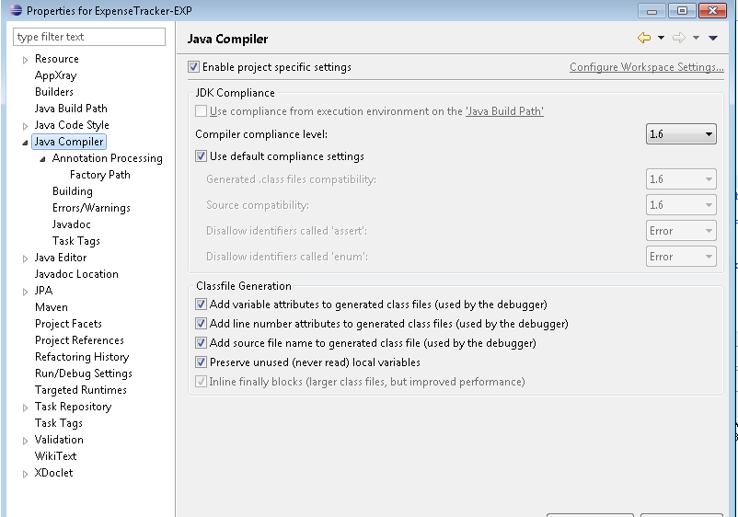

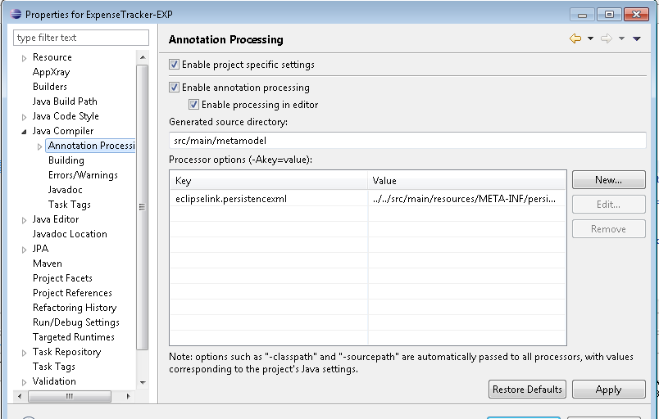
eclipselink.persistencexml ../../src/main/resources/META-INF/persistence.xml

